**Unit Testing Document**

1. **Test Case: Checking with decimal Input.**

**Input:**

Please Enter The Product Price :

23.66

Please Enter Paid Amount :

50

Expected Result

--------------------------

Your Change is :

2 x £10

1 x £5

1 x £1

1 x 34p

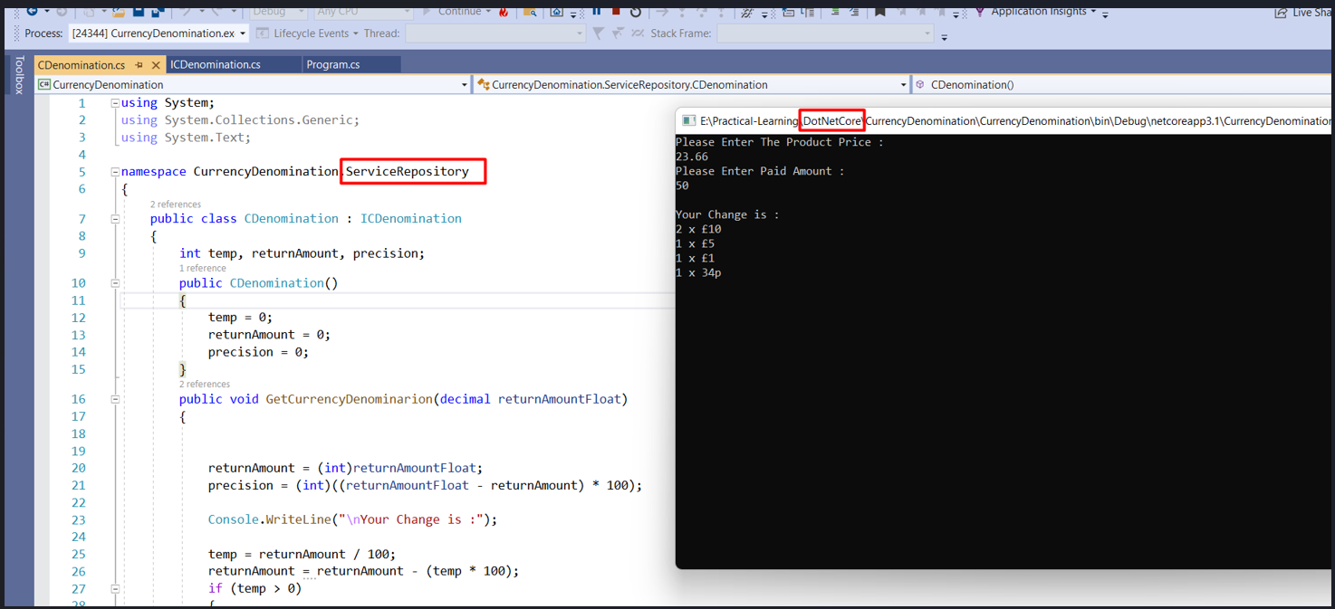

**2 Test Case : Checking with the whole number**

Please Enter The Product Price :

36

Please Enter Paid Amount :

50

Expected Result

--------------------------

Your Change is :

1 x £10

2 x £2

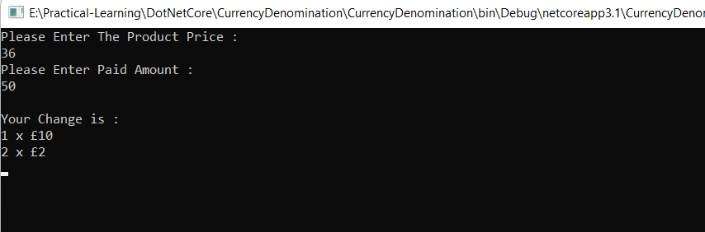

**3 Test Case : Incorrect Input format**

Please Enter The Product Price :

Kdakjd

**Expected**

Below issue has been occured

Input string was not in a correct format**.**

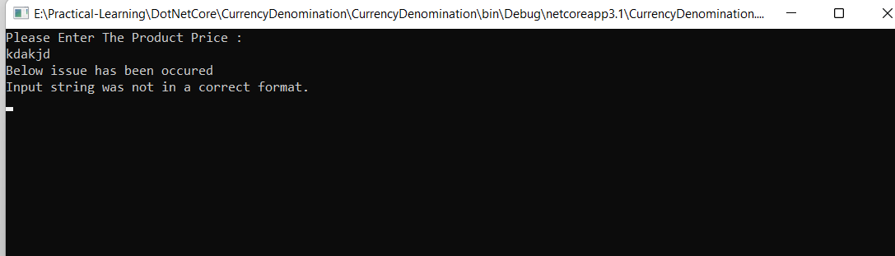

**4 Test Case : If Paid amount less than Product Price.**

Please Enter The Product Price :

36

Please Enter Paid Amount :

20

**Expected**

Paid amount is less than Product amount, Please Enter Correct amount.Input string was not in a correct format**.**

